Local Market Price Tracker for Agricultural Commodities in Uganda
Student: OPAMAN MICAIAH JOSHUA | Reg No: S25M19/038 | Access No: B35677

1. Introduction
This project delivers a Python-based, object-oriented application that records, stores, and visualizes daily market prices for key agricultural commodities. It is optimized for offline/low-connectivity contexts using a local SQLite database and a simple command-line interface (CLI).

2. Problem Statement
Smallholder farmers and local traders often lack timely, consolidated market price information. Prices vary by market and day, limiting bargaining power and planning. A lightweight, offline-capable tracker can close this gap.

3. Objectives
• Design a modular OOP codebase for market price tracking.
• Store and retrieve records using SQLite.
• Generate clear price-trend visualizations for analysis.
• Provide sample data and documentation for ease of use.

4. Methodology & Design
The application is structured around the following classes:
- Product, Market, PriceRecord: Lightweight data models (dataclasses).
- DatabaseManager: Encapsulates SQLite schema, CRUD operations, and time-series queries.
- Plotter: Builds Pandas DataFrames and renders Matplotlib line charts.
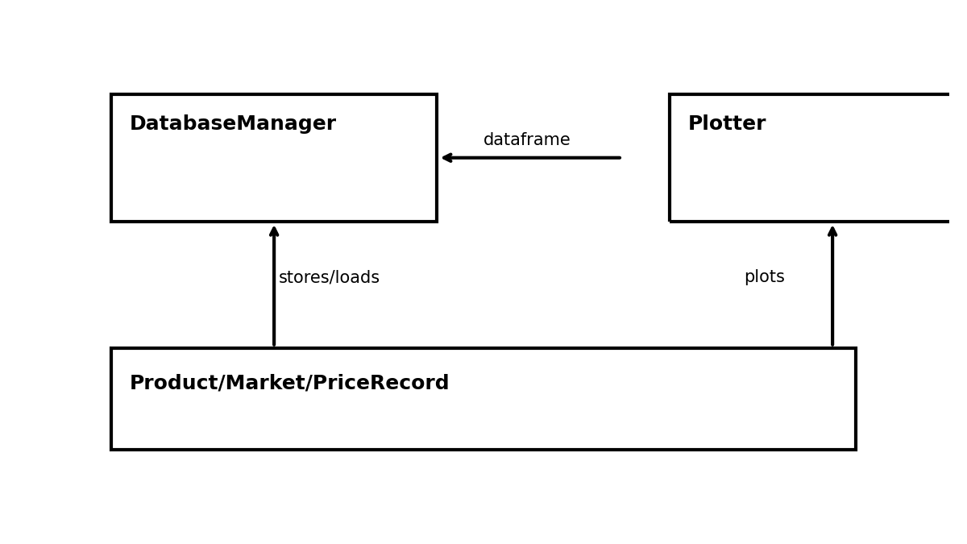

5. Implementation Details
Key design choices:
- SQLite for local, zero-setup persistence.
- Pandas for tabular transformations; Matplotlib for plots.
- Deterministic sample-data generation with realistic noise and weekly seasonality.

6. Screenshots (Sample Outputs)
trend_maize.png
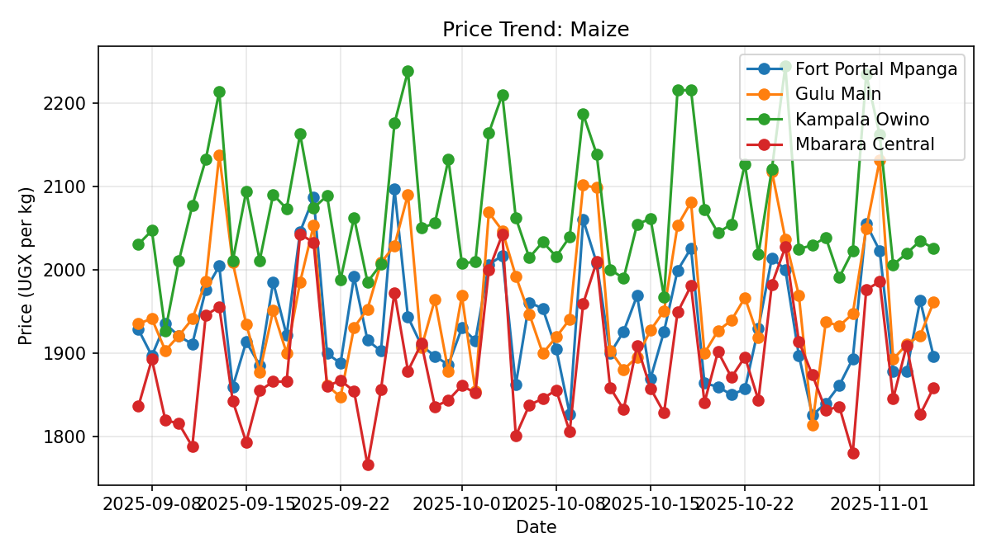
trend_beans.png
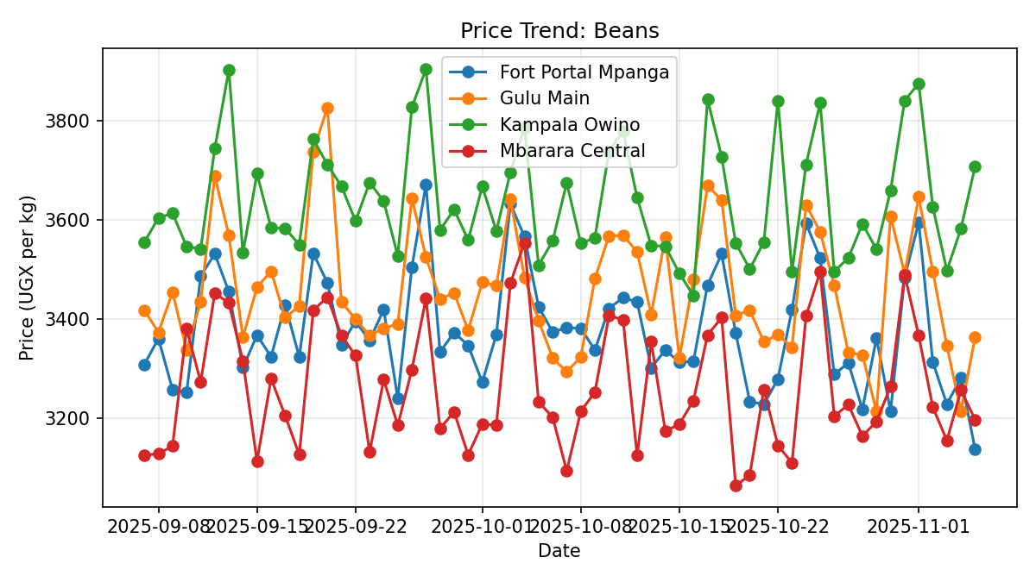
trend_matoke.png
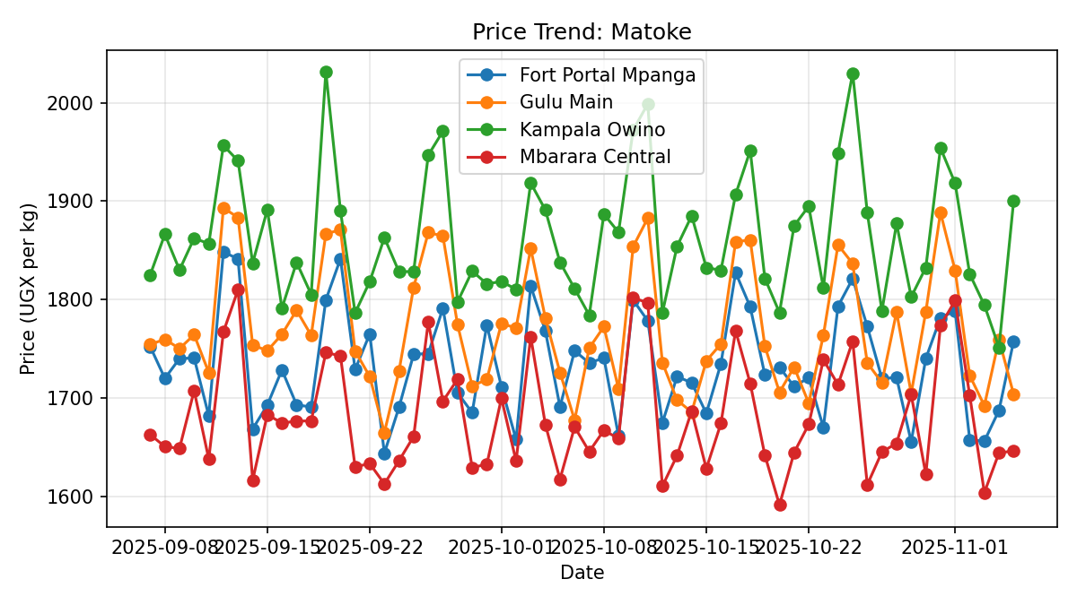
trend_groundnuts.png
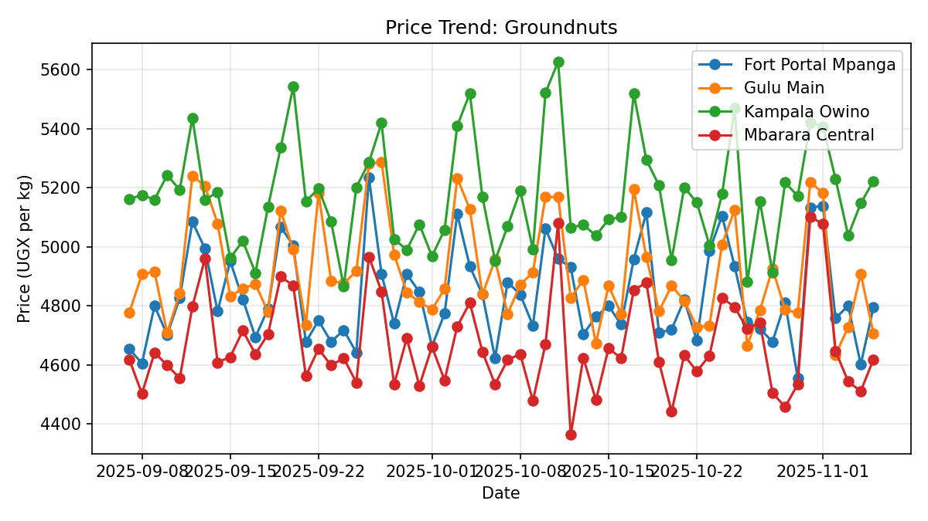
system_design.png

7. Expected Outcomes
• A working CLI/OOP application with SQLite storage.
• Trend charts that reveal short-term fluctuations and weekly patterns.
• Reusable codebase ready for future GUI/SMS integrations.

8. Future Enhancements
• Import/export CSV and Excel; scheduled data entry.
• User roles and simple authentication for cooperatives.
• SMS/USSD input for low-end phones; API sync to national datasets.
• Alerting: Price thresholds and anomaly detection.

9. Conclusion
The project demonstrates practical OOP design, local persistence with SQLite, and insightful visual analytics tailored to Uganda’s agricultural markets.

